 | Template Rapport de Stage Obligatoire d’Eté | Code : DO-PFE-01
 | Template Rapport de Stage Obligatoire d’Eté | Indice de révision : 00
 | Template Rapport de Stage Obligatoire d’Eté | Edition : 07/2022

Rapport de Stage Obligatoire d’Eté

Filière : Génie Logiciel
Niveau : 4^{ième} Année

Sujet :

Medical Chatbot Development using a fine-tuned LLM, RAG & NER

Réalisé par : Fendri Adam

Entreprise d’accueil :

Pura Solutions

Année Universitaire : 2023/2024

 | Template Rapport de Stage Obligatoire d’Eté | Code : DO-PFE-01
 | Template Rapport de Stage Obligatoire d’Eté | Indice de révision : 00
 | Template Rapport de Stage Obligatoire d’Eté | Edition : 07/2022

Rapport de Stage Obligatoire d’Eté

Filière : Génie logiciel
Niveau : 4^{ième} Année

Sujet :

Medical Chatbot Development using a fine-tuned LLM, RAG & NER

Réalisé par : Adam Fendri

Entreprise d’accueil :

Pura Solution

Responsable à l’entreprise:  Mme Jawaher chatbri | Avis de la commission des stages

Année Universitaire :
2023/2024

Introduction:
The rapid advancement of artificial intelligence (AI) has had a transformative impact on the healthcare industry, particularly through the development of intelligent systems that can assist in patient care and diagnosis. This report documents the work accomplished during my internship at Pura Solutions, focusing on the development of a medical chatbot system. The primary objective was to build an AI-driven assistant capable of understanding and analysing medical inquiries to provide relevant and reliable information to patients.
To achieve this, the project involved fine-tuning a large language model (LLM), Gemma2 2B, specifically adapted for medical contexts. The chatbot also integrates a Named Entity Recognition (NER) model based on RoBERTa to extract critical information, such as a patient's age, weight, and height. Furthermore, a Retrieval-Augmented Generation (RAG) system was implemented to enhance the chatbot's ability to provide contextually appropriate answers. Finally, a summarization model, T5, continuously updated the conversation summary, ensuring coherent and concise records of patient interactions. Through these integrated AI components, the chatbot aims to assist in preliminary medical assessments and guide patients effectively.

Presentation of the host company
2.1 Company Overview :
PURA Solutions is a pioneering company established in 2021, specializing in the development of advanced AI-driven hardware and software solutions for the biotechnological and medical sectors. Their mission is to revolutionize healthcare through technological innovation, offering tailored products and services that address critical challenges in the medical industry.
Sector of Activities:
PURA Solutions operates at the intersection of biotechnology and medicine, focusing on:
- Innovative Product Development: Designing and developing state-of-the-art medical devices and software solutions, including AI-driven innovations and educational medical equipment like the PURA-DefibrillateurEdu.
- Biotechnological Advancements: Leveraging scientific research and cutting-edge technology to create solutions that address equipment shortages and enhance healthcare standards.
- Client-Centric Services: Providing customized solutions tailored to the unique needs of each client, ensuring adaptability and alignment with the operational requirements of healthcare institutions.
2.2 Organizational Structure:
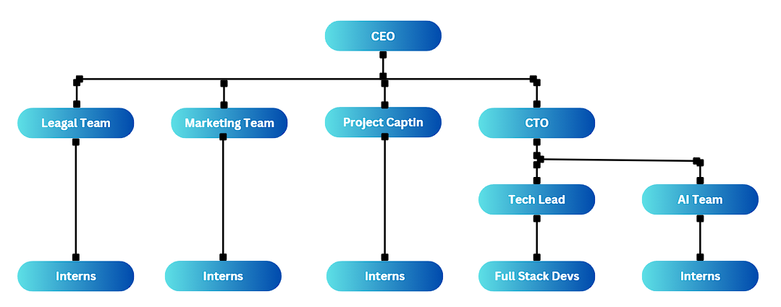
2.3 Services Offered:
PURA Solutions offers a comprehensive range of services, including:
- Conception and Development: Crafting innovative hardware and software solutions tailored to the specific needs of the biotechnological and medical sectors.
- Guidance and Consulting: Assisting clients in shaping customized products aligned with their unique requirements.
- After-Sales Support: Offering robust after-sales services to guarantee seamless integration and operation of solutions within client environments.
- Sales Services: Ensuring a smooth and efficient procurement process for flagship products.
For more information, visit their website: PURA Solutions[1].

Objectives(Project Scope):
The objective of this medical chatbot project is to enhance patient analysis and illness guidance using advanced AI technologies. Designed to replace routine tasks handled by human assistants, the chatbot supports doctors by extracting patient details, analyzing symptoms, and providing relevant medical insights. Its conversation summarization feature ensures efficient case reviews for healthcare professionals.
Ultimately, the assistant will be integrated into a website, making it widely accessible. As a research and development (R&D) initiative, this project aims to push the boundaries of medical AI and improve healthcare delivery.

Journal de stage
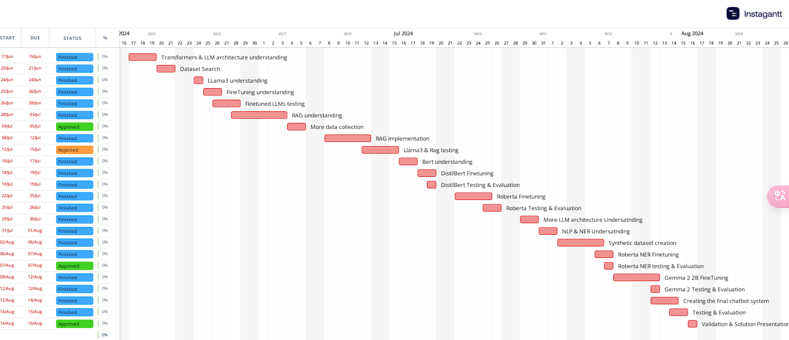
For a more detailed high resolution image, check out the github repo.

Travail réalisé:
5.1 Understanding and Implementing Transformers:

The foundation of our medical chatbot system lies in the Transformer architecture. Transformers have revolutionized NLP by addressing key limitations in earlier models, such as Recurrent Neural Networks (RNNs) and Long Short-Term Memory networks (LSTMs), which struggled with long-term dependencies and were prone to vanishing gradient problems.
- Self-Attention Mechanism: Central to the Transformer is the self-attention mechanism, which allows the model to weigh the significance of each word in a sentence relative to every other word. This mechanism uses three key components: Queries, Keys, and Values, which enable the model to focus on different parts of the input sequence. In the medical context, this allows the chatbot to interpret symptoms and health conditions with appropriate attention to critical medical terms.
- Positional Encoding: Since Transformers do not process data sequentially (like RNNs), they require positional encodings to understand the order of words. Positional encoding is crucial in ensuring that the model understands the sequence of words in a sentence, which is particularly important for medical conversations where the order of symptoms or events can change the meaning.

5.2 BERT and RoBERTa Architectures for NER:

The chatbot heavily relies on Named Entity Recognition (NER) to extract patient-specific information such as age, weight, and height from user input. This is achieved using models like BERT and RoBERTa:
- BERT (Bidirectional Encoder Representations from Transformers): BERT’s architecture is bidirectional, meaning it looks at words in both directions (left-to-right and right-to-left) to understand context. This bidirectionality makes it highly effective for tasks that require a nuanced understanding of language, such as entity extraction.
- RoBERTa (Robustly Optimized BERT Approach): RoBERTa builds on BERT by improving the training methodology. It removes the Next Sentence Prediction objective used in BERT and increases training data size and mini-batch sizes. These enhancements make RoBERTa better suited for our NER task, where precise extraction of medical information is essential.
- Custom NER Dataset: To fine-tune RoBERTa for our needs, I created a custom dataset with 1,000 synthesized samples that included realistic medical conversations embedded with age, height, and weight details. Each sentence was manually annotated using the B-I-O tagging scheme (Beginning, Inside, Outside), which is crucial for accurately training NER models.

5.3 Q-LORA (Quantized Low-Rank Adaptation) for Efficient Model Fine-Tuning:

Given the resource constraints involved in deploying and fine-tuning large language models (LLMs) such as LLaMA3 and Gemma2 2B, Q-LORA (Quantized Low-Rank Adaptation) was employed as a highly efficient method for model adaptation. Here's an in-depth explanation of how Q-LORA operates and the fine-tuning process:
Concept of Q-LORA
Q-LORA is an advanced technique that combines two main strategies to efficiently fine-tune large-scale models:
- Low-Rank Adaptation (LoRA) Mechanism:
  - Problem with Full Fine-Tuning: Normally, fine-tuning an LLM involves updating a massive number of parameters, which is computationally expensive and requires significant memory. This is particularly challenging for models with billions of parameters, like Llama3 8B.
  - LoRA Solution: Instead of updating all parameters, LoRA introduces small, low-rank matrices into the attention layers of the Transformer architecture. These matrices, known as "rank reduction matrices," are trained to capture task-specific information. During inference, the original model’s parameters remain frozen, and only these newly introduced low-rank matrices contribute to the model’s output.
  - How It Works: In LoRA, the weights of the attention layers, W, are decomposed into two smaller matrices, A and B, such that: W′=W+α⋅A⋅BW'
Here:
    - W: The original weight matrix of the attention layer.
    - A and B: Low-rank matrices with much smaller dimensions (e.g., rank 4 or 8), which are trained during fine-tuning.
    - α: A scaling factor that controls the influence of the low-rank adaptation.
  - Advantages: This approach drastically reduces the number of parameters that need to be adjusted, making the fine-tuning process much more memory-efficient and computationally feasible. By focusing on these low-rank matrices, LoRA ensures that the most significant aspects of the model are fine-tuned for the specific task, without overhauling the entire network.
- 4-bit Quantization:
  - Why Quantization?: LLMs are typically trained and stored using 16-bit or 32-bit floating-point precision, which consumes a substantial amount of memory. Quantization reduces the precision of these weights, compressing the model and reducing memory usage.
  - How 4-bit Quantization Works: In Q-LORA, the weights of the Transformer model are quantized from 32-bit floating-point precision to 4-bit integer representation. This means that each weight value is stored using only 4 bits instead of 32 bits, resulting in an 8-fold reduction in memory usage. The quantization process maps the continuous range of weight values to a smaller set of discrete values, while carefully minimizing the loss of information.
  - Challenges and Solutions: One challenge with quantization is the potential degradation of model performance due to the loss of precision. However, Q-LORA addresses this by carefully choosing which layers and parameters to quantize and applying scaling factors to maintain model quality. For instance, sensitive parameters, like those in the embedding layers, may remain in higher precision, while less critical layers are quantized.

Fine-Tuning Process Using Q-LORA
- Inserting LoRA Layers:
  - LoRA layers are inserted into specific parts of the Transformer model, typically the attention layers. These layers are initialized with small random values and gradually learn task-specific representations during fine-tuning.
  - During each forward pass, the output of the original attention layer is modified using the LoRA layers. The original computation XW (where X is the input and W is the weight matrix) is augmented as X(W+α⋅A⋅B)X. Here, A and B are the learnable low-rank matrices, and α is a scaling factor.
- Training and Optimization:
  - The model is fine-tuned using task-specific data, in this case, medical dialogues and queries relevant to the chatbot’s purpose. The optimization process only updates the parameters of the LoRA layers (i.e: A and B), while the rest of the model remains frozen.
  - Loss functions like Cross-Entropy Loss are used to guide the training process. For text generation tasks, special attention is given to the alignment of generated responses with ground truth medical information, ensuring accuracy and coherence.
- Efficiency and Performance:
  - By updating only the low-rank matrices and using 4-bit quantization, Q-LORA enables the fine-tuning of massive models on GPUs with limited memory. Despite the reduced precision, the model retains high performance, making it practical for deployment in real-world applications, such as the medical chatbot.

5.4. RAG (Retrieval-Augmented Generation) for Contextual Responses:

The chatbot’s ability to deliver medically accurate, evidence-based, and context-aware information is fundamentally supported by the RAG architecture. This approach is highly suitable for applications where the reliability and relevance of the information are critical, such as healthcare.
How RAG Works
RAG, or Retrieval-Augmented Generation, is a hybrid framework that combines two powerful components to generate responses:
- Retriever: The retriever’s role is to search and extract relevant pieces of information from a large corpus of documents. In this project, the retriever uses a dense retrieval method, meaning it maps both queries (user inputs) and documents (medical texts) into a shared vector space. The goal is to maximize the similarity between the query and the most relevant documents. The steps involved are:
  - Query Embedding: When a user inputs a query (for example, a question about a symptom), the query is transformed into a dense vector representation using a pre-trained HuggingFace embedding model. This vector captures the semantic meaning of the query.
  - Document Retrieval: The retriever then searches through the knowledge base, which has been indexed using FAISS (Facebook AI Similarity Search), to find documents that have the highest cosine similarity with the query vector. FAISS is a highly efficient library that performs fast similarity search and clustering of dense vectors, making it ideal for large-scale retrieval tasks.
- Generator: Once the relevant documents are retrieved, they are fed into a language model (such as Gemma2 2B or LLaMA3) that acts as the generator. The generator uses the information from the retrieved documents to craft a well-informed, coherent, and contextually relevant response. This response is then provided to the user. The generator is trained to condition its output on both the original user query and the retrieved context, ensuring that it can synthesize information from multiple sources and present it in a way that is easy to understand.
Implementation Details
- FAISS Database:
  - What is FAISS?: FAISS (Facebook AI Similarity Search) is a library developed by Facebook AI Research that is optimized for searching through large collections of dense vectors. In the context of our chatbot, FAISS is used to index and search a vast database of medical documents efficiently. It allows us to perform nearest-neighbor searches at high speed, which is crucial for real-time applications like a chatbot.
  - Indexing Process: The medical literature, which consisted of PDF medical books approved by the CEO (a BIO engineer), was pre-processed and converted into a collection of dense vector representations using HuggingFace embeddings. These embeddings capture the semantic meaning of each document, making it possible to perform meaningful similarity searches. The FAISS index was then built using these vectors, allowing for efficient retrieval during user interactions.
  - Search Efficiency: FAISS supports various indexing methods, such as Inverted File (IVF) indices and Product Quantization (PQ), which reduce memory usage while maintaining high retrieval accuracy. We selected an indexing method that balanced speed and precision to ensure that the chatbot could deliver quick yet reliable answers.
- HuggingFace Embeddings:
  - Pre-trained Embedding Models: We used pre-trained embedding models from HuggingFace to transform both the user queries and the medical documents into dense vectors. These models are trained on large amounts of text data and are designed to capture the semantic meaning of sentences, which is essential for understanding complex medical queries.
  - Embedding Process: When embedding the documents, each medical text was split into smaller, manageable chunks to ensure that the embedding model could process them effectively. This chunking process is important because it allows for a more granular search, where the retriever can match specific parts of a document to the user’s query rather than having to retrieve an entire document.
- Data Sources:
  - PDF Medical Books: The core of the knowledge base consisted of approved medical literature provided in PDF format. After obtaining explicit approval from the CEO, who is a BIO engineer, these documents were pre-processed for indexing. The PDFs were converted into text, and any extraneous content (like tables of contents or footnotes) was removed to ensure that the retriever only indexed high-quality medical content.
  - Ethical Considerations: Ensuring the use of authoritative and reliable sources was critical, given the sensitive nature of medical information. The approval from the CEO ensured that the data was both ethically sourced and medically accurate.
- How the RAG System Enhances Responses:
  - Contextual Relevance: By using the RAG framework, the chatbot can provide responses that are grounded in real, authoritative medical literature. This is particularly important in healthcare, where the accuracy of information can have significant consequences. The RAG system ensures that responses are not only grammatically and syntactically correct but also backed by verified medical knowledge.
  - Dynamic Information Retrieval: The RAG system allows for dynamic retrieval of the most relevant information. For example, if a patient asks about symptoms of a rare disease, the retriever can fetch up-to-date medical definitions, case studies, or treatment guidelines. The generator then uses this information to construct a response tailored to the patient’s needs.
- Challenges and Optimizations:
  - Balancing Speed and Accuracy: One of the main challenges in implementing RAG was ensuring that document retrieval was both fast and accurate. FAISS’s indexing methods and the use of efficient embedding models were key to overcoming this challenge.
  - Handling Ambiguity in Queries: Medical questions can often be ambiguous or vague. To address this, the RAG system uses multiple retrieved documents to provide a comprehensive answer, covering different aspects of the user’s question.

5.5. Model Experiments and Learning:

Throughout the development process, several experiments were conducted to optimize model performance:
- DistilBERT and RoBERTa for Q&A: Initially, I experimented with using DistilBERT and RoBERTa for question-answering tasks. However, these models, while efficient for classification and NER tasks, failed to generate coherent and meaningful answers. This failure underscored the importance of using models specifically designed for text generation.
- Subset Training on LLaMA3: To explore data efficiency, I split the custom dataset into ten smaller subsets and trained LLaMA3 on Kaggle. However, due to hardware limitations and the complexity of generative tasks, these attempts did not yield the desired results, leading to a strategic pivot towards Gemma2 2B fine-tuning with Q-LORA.

5.6. Testing and Evaluation
The project involved rigorous testing and evaluation to ensure the chatbot's reliability and accuracy:
- Gemma2 2B Evaluation: The fine-tuned Gemma2 2B model was assessed using metrics like BLEU and ROUGE to measure the quality of text generation. Evaluation loss and accuracy were also monitored throughout the training process. The model demonstrated strong performance, with low evaluation loss and high BLEU and ROUGE scores, indicating that it generated coherent and relevant medical advice.
- NER Model Performance: The RoBERTa model achieved an impressive F1 score of 92%, reflecting its high accuracy in extracting patient-specific information. Precision and recall scores were also balanced, showing that the model was effective at both identifying relevant entities and minimizing false positives.

5.7. System Integration and Final Assembly
The final step involved integrating all components into a unified system:
- NER Integration: The RoBERTa NER model was incorporated into the chatbot to extract patient information dynamically. This data was then used by the generative models to tailor medical responses to the user's needs.
- RAG System Integration: The FAISS-based RAG system was linked to the generative models, allowing the chatbot to reference external medical documents and provide evidence-based responses.
- T5 Summarization: A T5 model was used to continuously summarize ongoing conversations. This feature is crucial for healthcare professionals who need to quickly review patient interactions, ensuring that important details are readily accessible.

- 8. Challenges and Lessons Learned
- Model Limitations: The experiments with DistilBERT and RoBERTa highlighted the importance of understanding model architectures and their suitability for different NLP tasks. This experience reinforced the value of models like LLaMA3 and Gemma2 for text generation.
- Data Constraints: Working with large models on limited hardware required innovative solutions like Q-LORA and the use of cloud GPUs. These constraints taught me the importance of efficient resource management and the trade-offs between model size, precision, and performance.

Consolidation des acquis
A travers un tableau, résumer les compétences acquises lors de votre formation à l’INSAT (matières, cours enseignés) par rapport aux habilitations ″Skills″ acquissent durant le stage d’été.

Conclusion
La conclusion du rapport est une synthèse du travail effectué durant le stage. Souligner les points forts et les points faibles. Il est recommandé d’appuyer vos conclusions par des ratios et des chiffres. Interroger vous sur la suite, sur l’avenir de l’entreprise, sur le service, et mettre en perspective votre stage dans votre formation.

Bibliographies
Les références bibliographiques sont numérotées par ordre croissant au fur et à mesure de leur apparition dans le texte, en chiffres arabes entre crochets par exemple ([1], [27], …). La bibliographie se déroule de [1] à [n].
Toutes les références de la liste doivent correspondre à des références citées dans le texte et vice versa.
Le style et la ponctuation des références doivent être conformes aux modèles illustrés dans les exemples suivants :
Ouvrage ou mémoire :
[1] Y. (1ère lettre du prénom Yassine) Chikhaoui (Nom de famille), Mécanique du point, Série Jean le Hir, MASSON, Paris, 1996.
Adresse Web :
[1] Z. Jaziri, F. Rouissi, http://www.mes.tn (adresse complète du site), consulté le préciser la dernière date de consultation.

